Project Title: Pakistan City Navigation System
The Pakistan City Navigation System is a console-based application designed to simulate a route-planning network for up to 8 cities. It utilizes fundamental Data Structures and Algorithms (DSA) to solve real-world problems regarding distance minimization and network cost optimization.
Objectives
- To implement and compare different Graph algorithms.
- To find the Shortest Path between two specific cities (Navigation).
- To calculate the Minimum Spanning Tree (MST) to connect all cities with minimum wire/road length (Network Planning).
All Algorithms Used
- Shortest Path:
  - Dijkstra’s Algorithm: Efficient for single-source shortest paths.
  - Floyd-Warshall Algorithm: Used for all-pairs shortest paths and matrix-based calculations.
- Minimum Spanning Tree (MST):
  - Kruskal’s Algorithm: Selects edges by weight (Greedy approach).
  - Prim’s Algorithm: Grows a tree from a starting node.
Major cities of Pakistan network map:
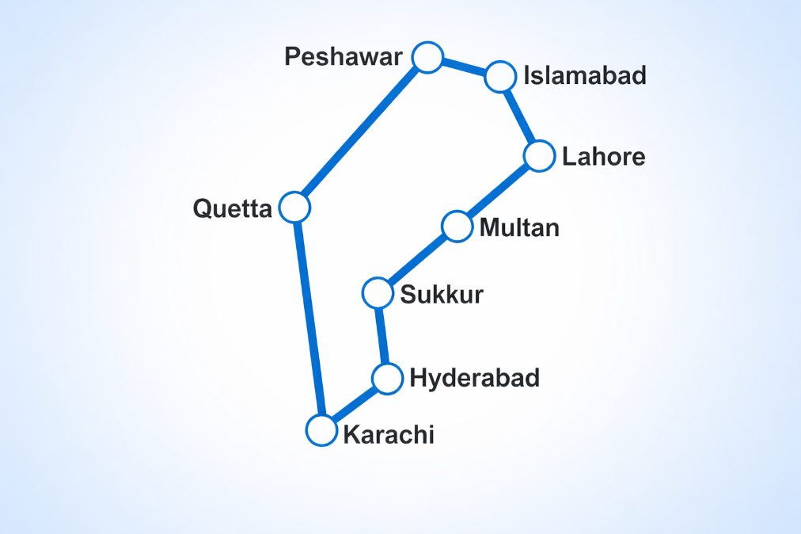
Dijkstra’s Algorithm: Efficient for single-source shortest paths.
The user initiates the process by selecting
Option 1 (Shortest Path) and providing Source ID 3 (Peshawar) and Destination ID 7 (Multan). Next, the user inputs
Option 1 to select Dijkstra's Algorithm, which triggers the internal function run_dijkstra(g, 3, 7) within the code. The algorithm then processes the weighted graph to calculate the minimum cost path, outputting the final route: Peshawar to Islamabad to Lahore to Multan.
Output:

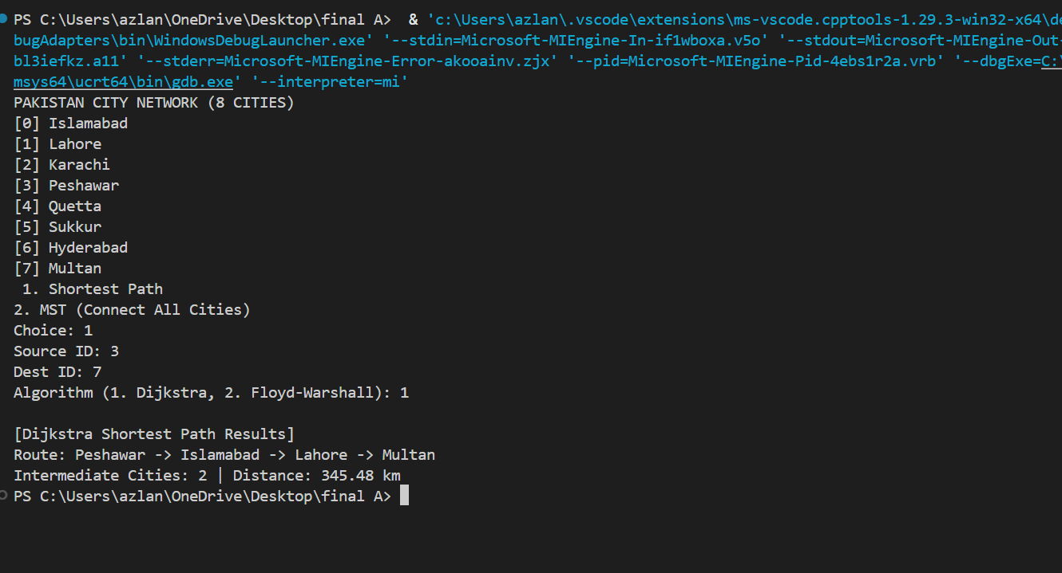
"We have successfully bridged the gap between theory and reality, creating a seamless tool that uses world-class algorithms to solve the real-world challenge of navigating Pakistan's major cities."

Floyd-Warshall Algorithm: Used for all-pairs shortest paths and matrix-based calculations.

To find the shortest path between cities, the user selects
Option 1 and specifies Source ID 3 (Peshawar) and Destination ID 7 (Multan). The user then chooses
Option 2, which calls the run_floyd_warshall function to perform an all-pairs shortest path analysis using dynamic programming. This results in the identification of the optimal route via Islamabad and Lahore, covering a total distance of 345.48 km.
Output:
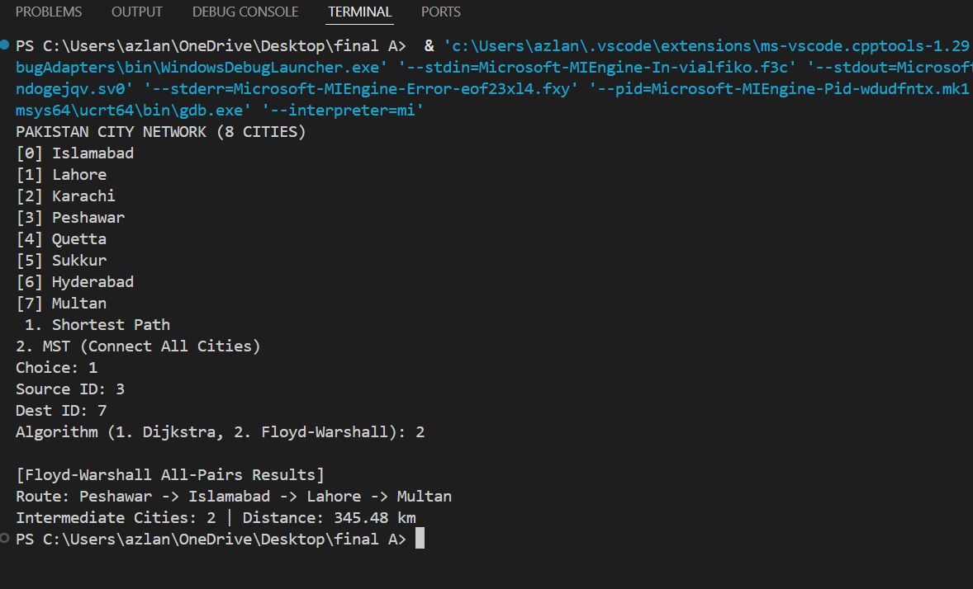

Prim’s Algorithm: Grows a tree from a starting node.

The user initiates the process by selecting
Option 2 (MST) and then enters
Option 1 to trigger the run_prim function. The algorithm grows the network from a starting city, evaluating edge candidates and marking them as "ACCEPTED" if they connect a new city or "REJECTED" if they create a cycle. The final output displays the optimized connections and calculates the Total Network Weight required to link all cities efficiently.
Output:
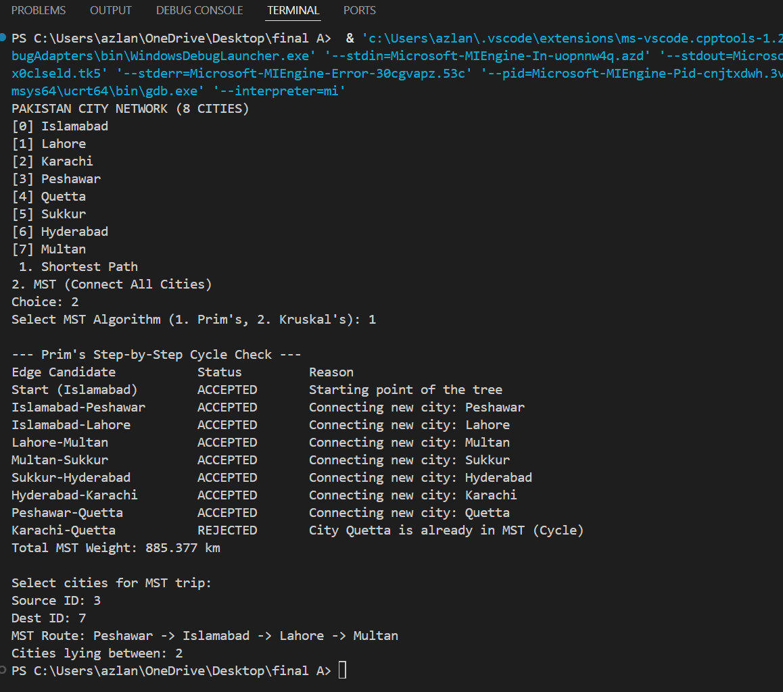

Kruskal’s Algorithm: Selects edges by weight (Greedy approach).

The user initiates the process by selecting
Option 2 (MST) and entering
Option 2 to call the run_kruskal function, which sorts all potential roads by weight to build a minimum-cost network. The algorithm evaluates each edge and assigns a status of "ACCEPTED" if it merges separate groups or "REJECTED" if both cities already belong to the same group, thereby preventing cycles. Upon completion, the system displays the step-by-step merging process and outputs the Total MST Weight of 885.377 km.
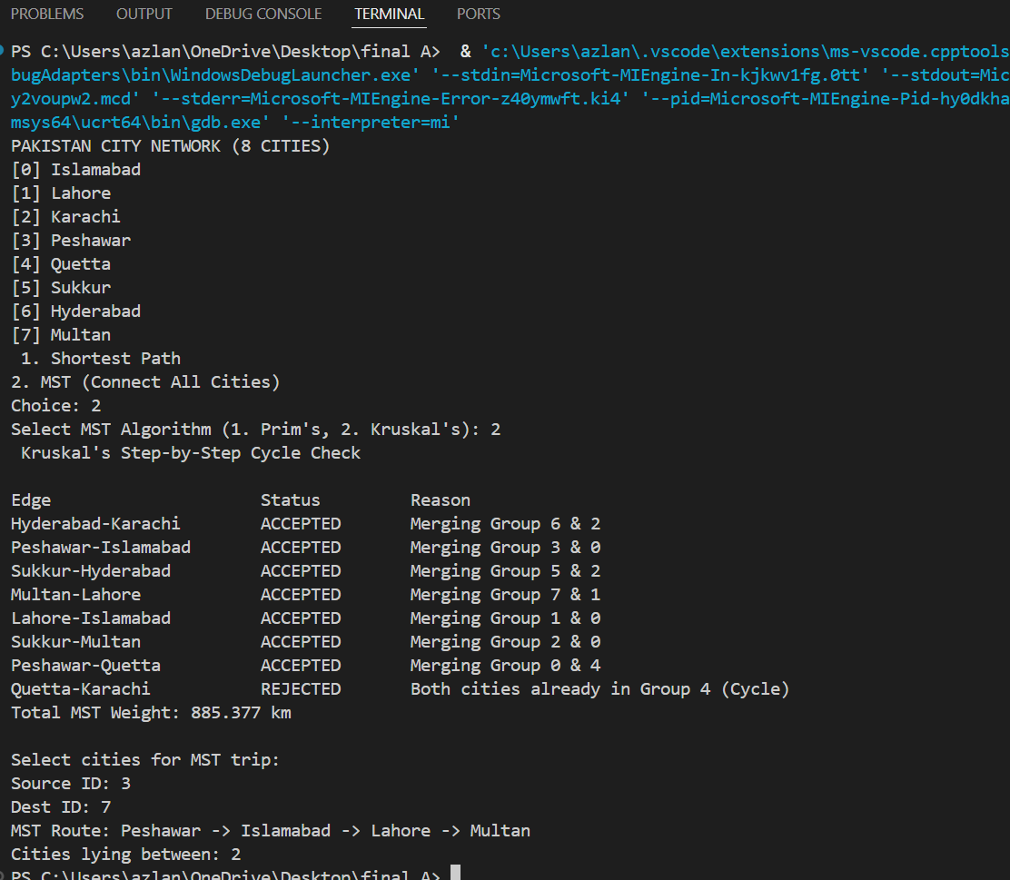
Alhamdulillah-Complete

Complete code Main.cpp

#include <iostream>
#include <string>
#include <iomanip>
using namespace std;
float get_dist(float x1, float y1, float x2, float y2) {
float n = (x2 - x1) * (x2 - x1) + (y2 - y1) * (y2 - y1), x = n, y = 1;
if (n == 0) return 0;
while (x - y > 0.01) { x = (x + y) / 2; y = n / x; }
return x;
}
void copy_str(char* d, const char* s) {
int i = 0; while (s[i] && i < 49) { d[i] = s[i]; i++; } d[i] = '\0';
}
struct Road {
int to;
float w;
Road* next;
};
struct City {
int id;
char name[50];
float x, y; Road* roads;
};
struct Edge {
int u, v;
float w;
};
struct Graph { City cities[8];
int cityCount;
Edge edges[30];
int edgeCount; };
struct MapEntry { int key;
float fVal;
int iVal;
MapEntry* next;
};
struct HashMap { MapEntry* table[10];
};
MapEntry* map_get(HashMap& m, int k) {
int h = (k < 0 ? -k : k) % 10; // h is index
MapEntry* c = m.table[h];
while (c) { if (c->key == k) return c;
c = c->next; }
MapEntry* n = new MapEntry{ k, 1e9f, -1, m.table[h] };
return m.table[h] = n;
}
struct HeapNode { float dist;
int u, v; };
struct MinHeap { HeapNode data[100];
int size; };
void heap_push(MinHeap& h,
float d,
int u,
int v = -1) {
int c = h.size++;
h.data[c] = { d, u, v };
while (c > 0 && h.data[(c - 1) / 2].dist > h.data[c].dist)
{
HeapNode t = h.data[c];
h.data[c] = h.data[(c - 1) / 2];
h.data[(c - 1) / 2] = t;
c = (c - 1) / 2;
}
}
HeapNode heap_pop(MinHeap& h) {
HeapNode top = h.data[0]; h.data[0] = h.data[--h.size];
int p = 0;
while (2 * p + 1 < h.size) {
int j = 2 * p + 1;
if (j + 1 < h.size && h.data[j + 1].dist < h.data[j].dist) j++;
if (h.data[p].dist <= h.data[j].dist) break;
HeapNode t = h.data[p]; h.data[p] = h.data[j]; h.data[j] = t; p = j;
}
return top;
}

void add_road(Graph& g, int u, int v) {
float w = get_dist(g.cities[u].x, g.cities[u].y, g.cities[v].x, g.cities[v].y); // w is weight
g.cities[u].roads = new Road{ v, w, g.cities[u].roads };
g.cities[v].roads = new Road{ u, w, g.cities[v].roads };
g.edges[g.edgeCount++] = { u, v, w };
}

void run_dijkstra(Graph& g, int start, int dest) {
HashMap dists = { 0 }, parent = { 0 }, vis = { 0 };
MinHeap pq = { 0 };
for (int i = 0; i < g.cityCount; i++)
map_get(dists, i)->fVal = 1e9f;
map_get(dists, start)->fVal = 0;
heap_push(pq, 0, start);
while (pq.size > 0) {
int u = heap_pop(pq).u;
if (map_get(vis, u)->iVal == 1) continue;
map_get(vis, u)->iVal = 1;
for (Road* r = g.cities[u].roads; r; r = r->next) {
float dU = map_get(dists, u)->fVal;
if (dU + r->w < map_get(dists, r->to)->fVal) {
map_get(dists, r->to)->fVal = dU + r->w;
map_get(parent, r->to)->iVal = u;
heap_push(pq, map_get(dists, r->to)->fVal, r->to);
}
}
}
if (map_get(dists, dest)->fVal > 1e8) { cout << "No path exists!\n"; return; }
int path[8], count = 0, curr = dest;
while (curr != start && curr != -1) { path[count++] = curr; curr = map_get(parent, curr)->iVal; }
cout << "\n[Dijkstra Shortest Path Results]\n";
cout << "Route: " << g.cities[start].name;
for (int i = count - 1; i >= 0; i--) cout << " -> " << g.cities[path[i]].name;
cout << "\nIntermediate Cities: " << (count > 1 ? count - 1 : 0) << " | Distance: " << map_get(dists, dest)->fVal << " km\n";
}
void run_floyd_warshall(Graph& g, int src, int dst) {
float d[8][8]; int next[8][8];
for (int i = 0; i < 8; i++) {
for (int j = 0; j < 8; j++) {
d[i][j] = (i == j) ? 0 : 1e9f;
next[i][j] = -1;
}
}
for (int i = 0; i < g.edgeCount; i++) {
int u = g.edges[i].u, v = g.edges[i].v;
d[u][v] = d[v][u] = g.edges[i].w;
next[u][v] = v; next[v][u] = u;
}
for (int k = 0; k < 8; k++)
for (int i = 0; i < 8; i++)
for (int j = 0; j < 8; j++)
if (d[i][k] + d[k][j] < d[i][j])
{ d[i][j] = d[i][k] + d[k][j];
next[i][j] = next[i][k]; }

if (next[src][dst] == -1) {
cout << "No path exists!\n";
return;
}
cout << "\n[Floyd-Warshall All-Pairs Results]\n";
cout << "Route: " << g.cities[src].name;
int curr = src, inter = 0;
while (curr != dst) {
curr = next[curr][dst];
cout << " -> " << g.cities[curr].name;
if (curr != dst) inter++;
}
cout << "\nIntermediate Cities: " << inter << " | Distance: " << d[src][dst] << " km\n";
}
bool find_mst_path(int curr, int target, Road* mstAdj[], int path[], int& count, bool vis[])
{
vis[curr] = true;
path[count++] = curr;
if (curr == target)
return true;
for (Road* r = mstAdj[curr]; r; r = r->next)
if (!vis[r->to] && find_mst_path(r->to, target, mstAdj, path, count, vis))
return true;
count--;
return false;
}

void query_mst_path(Graph& g, Edge mstEdges[], int edgeCount) {
int s, d; cout << "\nSelect cities for MST trip:\nSource ID: ";
cin >> s;
cout << "Dest ID: ";
cin >> d;
Road* mstAdj[8] = { nullptr };
for (int i = 0; i < edgeCount; i++) {
mstAdj[mstEdges[i].u] = new Road{ mstEdges[i].v, mstEdges[i].w, mstAdj[mstEdges[i].u] };
mstAdj[mstEdges[i].v] = new Road{ mstEdges[i].u, mstEdges[i].w, mstAdj[mstEdges[i].v] };
}
int path[8], count = 0; bool vis[8] = { false };
if (find_mst_path(s, d, mstAdj, path, count, vis)) {
cout << "MST Route: " << g.cities[path[0]].name;
for (int i = 1; i < count; i++) cout << " -> " << g.cities[path[i]].name;
cout << "\nCities lying between: " << (count > 2 ? to_string(count - 2) : "0") << endl;
}
}
void run_prim(Graph& g) {
HashMap vis = { 0 }; MinHeap pq = { 0 };
Edge mstEdges[8];
int mstCount = 0;
float totalWeight = 0;
heap_push(pq, 0, 0, -1);
cout << "\n--- Prim's Step-by-Step Cycle Check ---\n";
cout << left << setw(25) << "Edge Candidate" << setw(15) << "Status" << "Reason" << endl;
while (pq.size > 0) {
HeapNode e = heap_pop(pq);
string edgeName = (e.v == -1) ? "Start (Islamabad)" : string(g.cities[e.v].name) + "-" + string(g.cities[e.u].name);
if (map_get(vis, e.u)->iVal == 1) {
cout << left << setw(25) << edgeName << setw(15) << "REJECTED" << "City " << g.cities[e.u].name << " is already in MST (Cycle)" << endl;
continue;
}
map_get(vis, e.u)->iVal = 1;
if (e.v != -1) {
cout << left << setw(25) << edgeName << setw(15) << "ACCEPTED" << "Connecting new city: " << g.cities[e.u].name << endl;
mstEdges[mstCount++] = { e.v, e.u, e.dist }; totalWeight += e.dist;
}
else cout << left << setw(25) << edgeName << setw(15) << "ACCEPTED" << "Starting point of the tree" << endl;
for (Road* r = g.cities[e.u].roads; r; r = r->next)
if (map_get(vis, r->to)->iVal != 1)
heap_push(pq, r->w, r->to, e.u);
}
cout << "Total MST Weight: " << totalWeight << " km\n";
query_mst_path(g, mstEdges, mstCount);
}
int find_set(int i, int p[]) {
return (p[i] == i) ? i : p[i] = find_set(p[i], p); }
void run_kruskal(Graph& g) {
for (int i = 0; i < g.edgeCount - 1; i++)
for (int j = 0; j < g.edgeCount - i - 1; j++)
if (g.edges[j].w > g.edges[j + 1].w) {
Edge t = g.edges[j]; g.edges[j] = g.edges[j + 1]; g.edges[j + 1] = t; }
int p[8]; for (int i = 0; i < 8; i++) p[i] = i;
Edge mstEdges[8];
int mstCount = 0;
float totalWeight = 0;
cout << " Kruskal's Step-by-Step Cycle Check "<<endl;
cout<<" "<<endl;
cout << left << setw(25) << "Edge" << setw(15) << "Status" << "Reason" << endl;
for (int i = 0; i < g.edgeCount; i++) {
int rU = find_set(g.edges[i].u, p), rV = find_set(g.edges[i].v, p);
string edgeName = string(g.cities[g.edges[i].u].name) + "-" + string(g.cities[g.edges[i].v].name);
if (rU != rV) {
cout << left << setw(25) << edgeName << setw(15) << "ACCEPTED" << "Merging Group " << rU << " & " << rV << endl;
p[rU] = rV; mstEdges[mstCount++] = g.edges[i];
totalWeight += g.edges[i].w;
}
else cout << left << setw(25) << edgeName << setw(15) << "REJECTED" << "Both cities already in Group " << rU << " (Cycle)" << endl;
}
cout << "Total MST Weight: " << totalWeight << " km\n";
query_mst_path(g, mstEdges, mstCount);
}
int main() {
Graph g = { 0 };
auto add = [&](int i, const char* n, float x, float y) {
g.cities[g.cityCount] = { i, "", x, y, nullptr };
copy_str(g.cities[g.cityCount].name, n);
g.cityCount++;
};
add(0, "Islamabad", 715, 200);
add(1, "Lahore", 815, 300);
add(2, "Karachi", 570, 620);
add(3, "Peshawar", 650, 190);
add(4, "Quetta", 470, 370);
add(5, "Sukkur", 600, 480);
add(6, "Hyderabad", 580, 580);
add(7, "Multan", 710, 390);
add_road(g, 3, 0);
add_road(g, 3, 4);
add_road(g, 4, 2);
add_road(g, 5, 6);
add_road(g, 6, 2);
add_road(g, 5, 7);
add_road(g, 7, 1);
add_road(g, 1, 0);
cout << "PAKISTAN CITY NETWORK (8 CITIES)" ;
cout<<" "<<endl;
for (int i = 0; i < g.cityCount; i++) cout << "[" << i << "] " << g.cities[i].name << endl;
cout << " 1. Shortest Path\n2. MST (Connect All Cities)\nChoice: ";
int m; cin >> m;
if (m == 1) {
int s, d, algo;
cout << "Source ID: ";
cin >> s;
cout << "Dest ID: ";
cin >> d;
cout << "Algorithm (1. Dijkstra, 2. Floyd-Warshall): ";
cin >> algo;
if (algo == 1)
run_dijkstra(g, s, d);
else
run_floyd_warshall(g, s, d);
}
else {
int a; cout << "Select MST Algorithm (1. Prim's, 2. Kruskal's): ";
cin >> a;
if (a == 1) run_prim(g);
else run_kruskal(g);
}
return 0;
}
"Our Pakistan Navigation System is a powerful blend of smart logic and efficient design, transforming complex map data into the fastest routes and most cost-effective city networks."
< Alhamdulillah >

